**../../../../../../../Pictures/ARA/Pics/ARA%20LOGO/ARA%20master%20shield%20lo KENT ACTIVE ../../../../../../../Pictures/ARA/Pics/ARA%20LOGO/ARA%20master%20shield%20lo**

**THE NEWSLETTER OF KENT ACTIVE RETIREMENT ASSOCIATION**

**Volume: Seven Autumn 2021 No. 85**

***“Do not think of retirement as someone closing a door on a bright and crowded street.***

***Think of it as someone opening the door to a beckoning and uncluttered world.”***

**John Hardiman** *(Founder of the Association)*

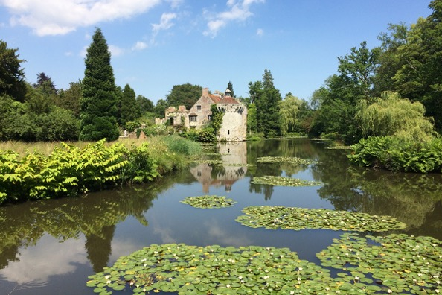

**Scotney Castle, Lamberhurst**

**Photograph by Graham Pover. Graham can be contacted at** [**gpoverphotography@btinternet.com**](mailto:gpoverphotography@btinternet.com)

**Dear Members,**

**We have some good news! Rochester Cathedral has been rebooked for the KentARA Thanksgiving service to be held provisionally on Thursday 27th October 2022 at 11am.**

**Individual Club secretaries can provisionally reserve their Clubs seating requirements/numbers, by emailing the KentARA secretary Lin Martin at** [**kentaramembershipsecretary@gmail.com**](mailto:kentaramembershipsecretary@gmail.com)

**Further information will be sent closer to the service.**

**The KentARA Cruise, (which celebrates the 25th Year of the foundation of KentARA) remains scheduled to depart on the 14th September 2022 from Dover, with only a few hammocks remaining available on Fred Olsens ‘Bolette’.**

**It is very ‘aFjordable’. See details on page 7.**

**Gerald Benham’s Tea Dance is running at Ditton Community Centre on Friday 12th November from 2pm-5pm. Please contact Gerald for further information on 01732 870 715, if you would like to go.**

**I hope you are all keeping well, I understand many members have been receiving their winter flu jabs, and a few have even had their Covid booster’s too.**

**Don’t forget to chase your G.P.’s if you have not heard from them with an offer of your seasonal Flu Jab, it is worth the wait on the phone to get through. You might even want to take matters into your own hands, and book your flu jab independently at your local pharmacy - it is free.**

**As for Covid, the infection rates seem to be increasing, but fatalities seem to be mercifully flat. This is a sure sign that the first two vaccinations have, and are working wonderfully well, and that we might be able to enjoy a more family orientated Christmas this year.**

**Nevertheless, don’t forget your masks in public, and the usual fastidious hand washing. Also don’t be shy in asking friends, and family to take a ‘Lateral Flow’ test (Blue Home ‘Covid’ Test Kit) before you go around, especially if you intend to spend a few hours indoors with them at Christmas, and New Year.**

**Below I have included a montage of pictures of my recent ‘Bolette’ tour, and a few snaps of Les, and I in Scotland to celebrate Les’s 25th Birthday.**

**Love,**

**Joan Rhodes**

**KentARA Chairlady**

**01732 844 953** [**rhodjo@aol.com**](mailto:rhodjo@aol.com)

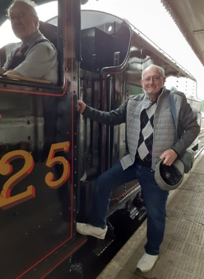 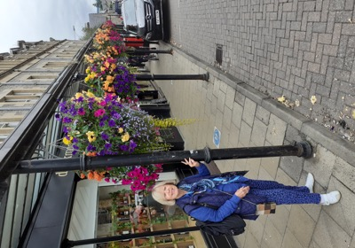**Scotland for the brave.**

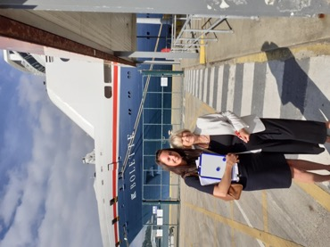 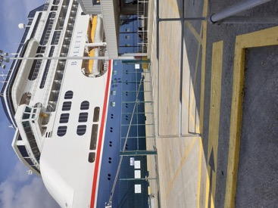

**Ettelob (The Bolette’s name when it reverses out of port).**

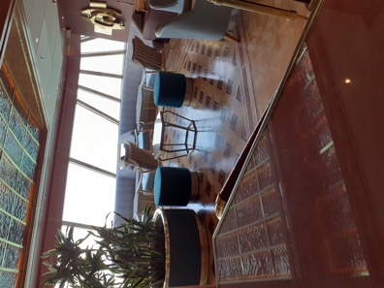 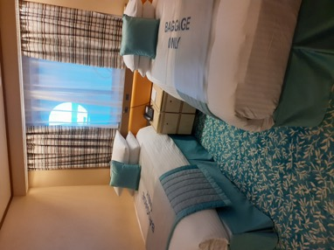

**Joan’s Suite - Living Room. Twin room for the Butler & Footman.**

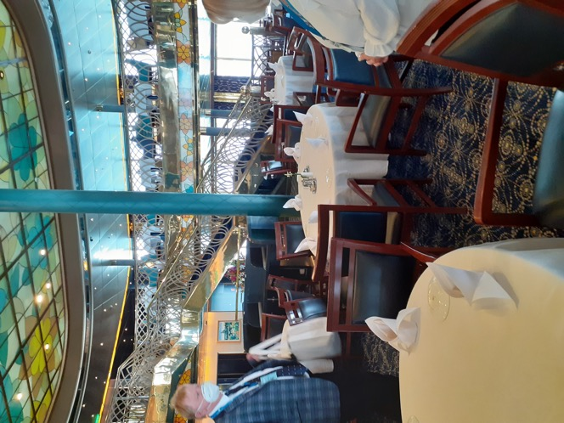

**Bolette’s two-storey Dining Room, one of a number of Restaurants.**

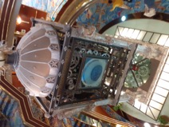

**Ships Clock so you don’t forget it’s more food again…**

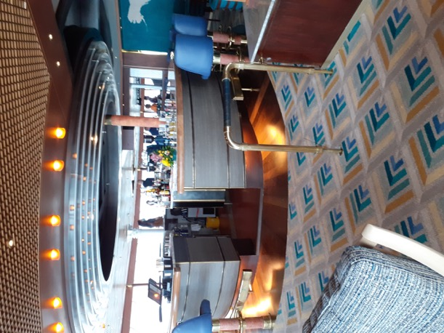

**The drinks are on Les – Cheers!**

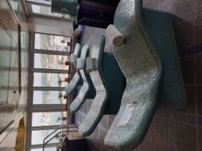

**…then Sober up in the Spa.**

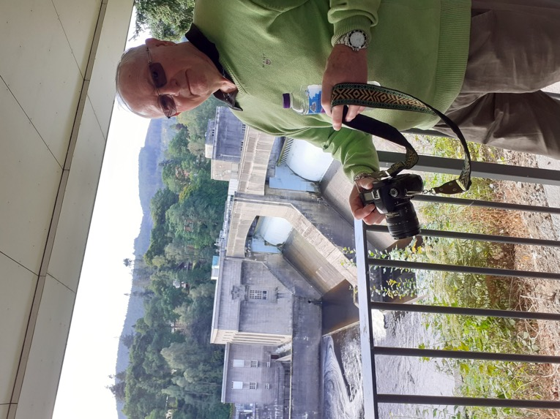

**…and finally, Les recharging his batteries at a Scottish Hydro Electric Plant,**

**Pitlochry.**

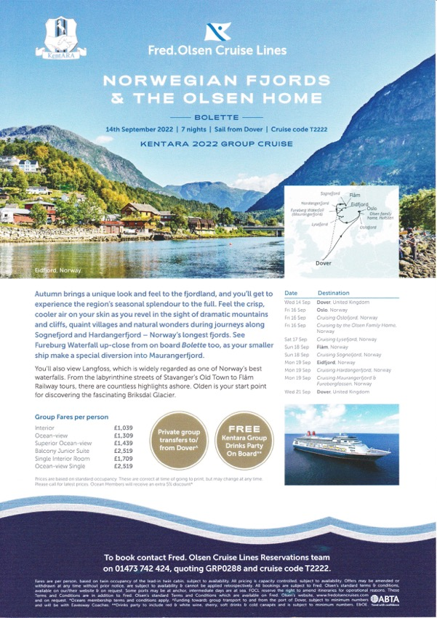

**RamARA – Ramsgate**

**After a long time waiting we are able to join in activities together, while still being careful where necessary.**

**Committee members have been telephoning our members every two weeks during the lockdown, just making sure everything was ok with them and, if not, trying to give assistance where they could.**

**We’ve had a Memorial Tea for members we have lost. This was over three days, keeping within the guidelines. The attendance was good.**

**Sequence Dancing is just beginning in our hall late morning.**

**On a Monday afternoon (weather permitting) Bat and Trap has returned, played on a local community football field. The attendance is rising each week and everyone has commented on how much fun they have.**

**Tuesday morning Gentle Exercise is back, again more members taking part each week. We have missed our exercises.**

**Tuesday late morning Line Dancing is happening, again with more members arriving each week.**

**For those more energetic, there is Table Tennis is on a Friday morning.**

**We’ve just come back from a Club Holiday to Kendal where a good time was had by all. The holiday included days out around the Lakes and a boat trip on Lake Derwent. Surprising how many places you can visit in three days.**

**In August we had over 90 at our belated Easter Tea party and a good time was had by all and the caterers did us proud. As you can see from the photo.**

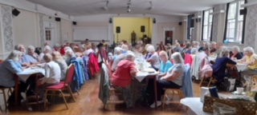

**At the end of August we have a Day Trip to the Prairie Gardens, with lunch.**

**We have a holiday in Bournemouth in September, our MacMillan Coffee Morning for charity, and a Day trip with a Boat Trip and Fish & Chips.**

**Every month we have either an entertainer or a speaker, and our Halloween Dance tickets are being sold for October.**

**We are a busy club with over 140 members and a great majority of them join in one of the above activities.**

**And even though we do not have lockdown now, some Ladies (Jan, Patricia, Margaret, Joan, Paula, Shirley, Violet, Chris, Jan, Laura, Doris, Ann, Margaret, Jan, Cyndy & Vera) are still knitting squares, or sewing up blankets ready for the next cold spell. So far around 67 Large, and 17 Small Blankets have been knitted, and given out to numerous Care Homes, Hospital, Dog Sanctuary, Salvation Army, etc.**

**Last, but not least we have a Tinsel and Turkey holiday to Weymouth during December. Our Christmas Tea Party, and then our Christmas Dinner!**

**Then on New Years Eve we have a Dance with food and music.**

**As you can see we are a very active club.**

**Jan Oxenham. RamARA Secretary**

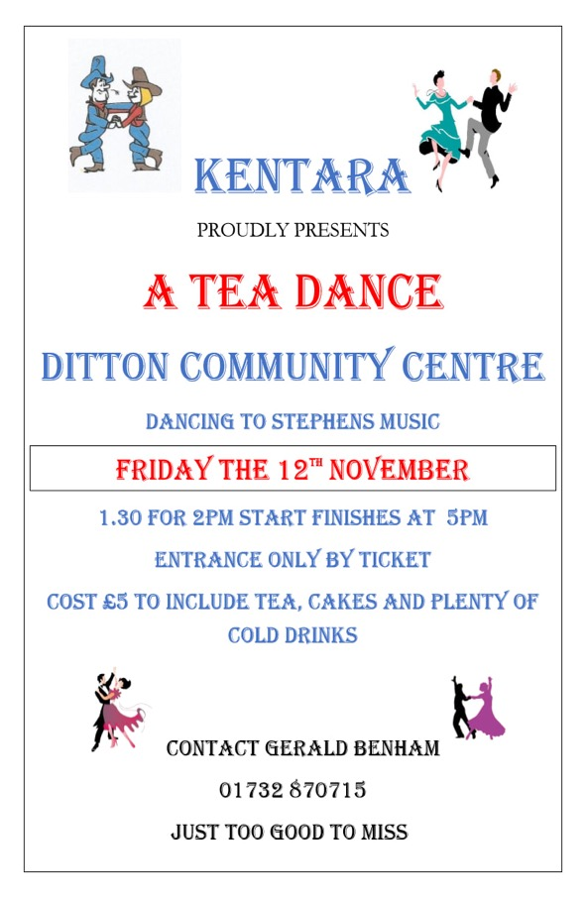

**TARA**

**THANET ACTIVE RETIREMENT ASSOCIATION**

**We had an earlier than usual breakfast, anxiously scanning the skies for clouds, and arrived at the coach pick-up point at 8.30 am. Yes, we were having a TARA outing; what excitement and anticipation. The driver greeted us as old friends - which we were, but we hadn’t seen him for nearly 2 years. We were surprised to go via the scenic alternative route to our destination - which was Hastings, but we just sat back, and enjoyed the camaraderie with banter, which has been missing from our lives for so long.**

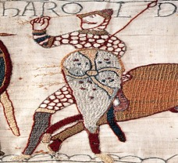

**It was a Battle getting there.**

**We went our separate ways to drink coffee, or something a little stronger, and had our favourite lunch of ‘Fish ‘n’ Chips’, licked an ice-cream cone, and strolled along the seaside taking in the sights of fishing boats, and the rides in the amusement park.**

**As we bumped into familiar faces, we chatted, and caught up with each other’s lives. For most of us the main destination was the ‘Hastings Contemporary Art Gallery’, which had a special exhibition called *‘Seaside Modern’*, which was a varied, and comprehensive series of pictures from commercial photographers, (before the day when everyone had the equipment to take their own photos), which was projected onto the wall. A lot of the images were of Thanet’s beaches, which was much appreciated.**

**Highlights from the exhibition included a print called, *‘Abstract’* by Ben Nicholson, which was on loan from the Tate, with instructions on how to hang it UPSIDE DOWN! A lovely seascape by Eric Revilious, long thought lost, turned up just before the show, but too late to be included in the catalogue. Elaine a chatty, and helpful volunteer gave us a lot of information about Edward Bawden, and his technique of pressing linocuts by pounding on them with his FEET! At the beginning of the gallery are seaside posters, given by LNER to the V & A. Obviously my favourite was of Redcar where I spent holidays, and days out in my childhood; the sky was an unbelievable cloudless blue - the artist was fresh from working on the French Riviera.**

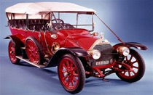

**Happy Memories in Red Car.**

**I saw nothing wrong with it as most of my memories are sunny. The general consensus for the favourite was a seascape of a non-specific location. We were pleasantly surprised as a**

**lot of us had been to the Lowry gallery in Salford, and couldn’t recall a painting set at the seaside.**

**After a welcome cup of tea in the balcony cafe at the gallery - with a superb view of the beach, and out over the very calm sea; a leisurely stroll took us back to the coach. Members had taken advantage of Hasting’s many offerings, and had enjoyed the Fisherman’s Museum, and the Smugglers’ Museum.**

**Unfortunately, the lift to the cliff top was out of order but it didn’t dampen our high spirits, and the enjoyment of a superb day out.**

**A raffle on the coach, and a direct road, soon had us home.**

**Our thanks go to the organiser Andrea Gunner, who also negotiated a very good price into the gallery, WELL DONE!**

**From, Norma Wright.**

**TARA Member**

**Halloween Special**

**Mrs. Pover’s Pumkin Allotment Patch, Aylesford.**



**Gourden Bennett, Scarecrow.**



**Gourd help us!**



**Gourden up to his knees in Shirt.**

***Pumpkins sponsored by the KentARA Squash team. What a racket*!**

**The KentARA website.** [**https://kentara.weebly.com/photos.html**](https://kentara.weebly.com/photos.html)

**For inclusion on the website, please send your Club pictures, and stories to**

**pmc1948@live.co.uk**

**Here we go again…**

**The Rochester Cathedral**

**KentARA Thanksgiving Service**

***‘Take Two’***

**Thursday 27th October 2022**

**11am**

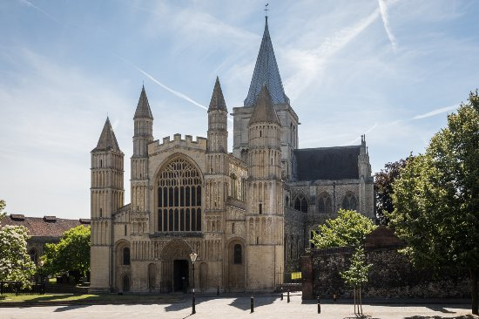

**Individual Club secretaries can provisionally reserve their Clubs seating requirements/numbers, by emailing the**

**KentARA secretary Lin Martin at,**

[**kentaramembershipsecretary@gmail.com**](mailto:kentaramembershipsecretary@gmail.com)

**Further information will be sent closer to the service.**